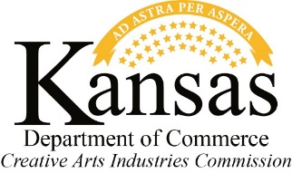
Kansas Latino Arts & Culture Roundtable

Nov 14, 2017
Johnson County Arts & Heritage Center
8788 Metcalf Ave
Overland Park, KS 66212

10:00am Welcome
Larry Meeker, Chair, Kansas Creative Arts Industries Commission

Project History
Peter Jasso, Director, Kansas Creative Arts Industries Commission

Group Introductions and Process Review
Evonne Gallardo, Arts & Culture Consultant

Local and National Cultural Context
- Demographics
- Regional Arts & Culture
- Local and National Latino Arts & Culture

BREAK

11:20am Kansas Latino Arts & Culture SWOT Exercise

Envisioning the Future of Latino Arts & Culture in Kansas and the region

LUNCH

12:30pm Exploring Strategies
        - What actions and strategies are needed to create a more connected, vibrant, and engaged Latino Arts and Culture field in Kansas and the region?

Next Steps

2:00pm Adjourn

