**After Successful Registration on behalf of – Business**

**Note: After successfully registering on behalf of the business, it is mandatory to get associated with the working account. This would be a one-time process and follow the steps below to get associated.**

* Go to <https://kansascommerce.my.site.com/Grants/s/> and log in using your Username and password.

When you scroll down you will see **Program Forms,** under that you will have two options:

1. **Add Account Relationship:**

* If you signed in on behalf of a business, then you must fill out the **Add Account Relationship** Form.

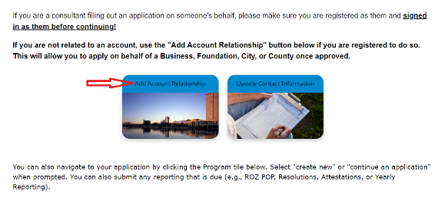

* After clicking on Add Account Relationship, if you have any pending requests, please try to fill out the form, and submit it under **Continue Account Relationship**. Otherwise, click on **Add Account Relationship** to create a new one.

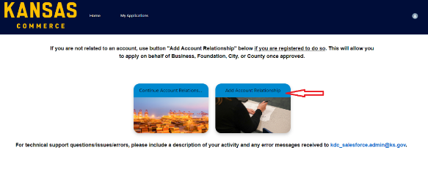

* If you go to Add Account Relationship, then the page looks like as shown below with the **Create Account Relationship** button.

* After going to the Create Account relationship, you must fill in the required information like Account Name, Account Type (County, Foundation, City, or Business), and Commerce Program (the program you want to apply).
* Click Next.

-To continue the request on behalf of a Business, Foundation, City, or County, click on **Continue Account Relationship Request** as shown below.

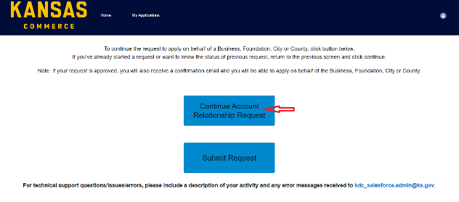

* After clicking on Continue Account Relationship Request, please fill out all the details and click on Search **for Account** on the next page click drop-down **Select Account** and see if the account on which you are applying appears in it,
* If shown in drop-down select the account and click **Continue,** else click Continue.

On the next screen please fill all the details to add or create your business record in our system. Once all the details are entered, please click on the “**Submit Section & Create Account”** Button.

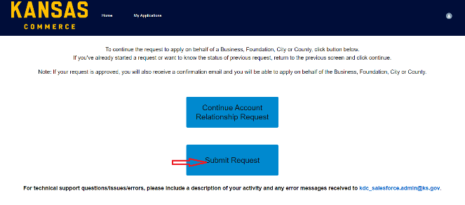

**If your request is approved, you will receive an email then you can come back to the portal and apply for the program.**

* If you are already done with submitting all the information which are required, then you can click **Submit Request**.

1. **Update Contact Information:**

* After filling out all the information, you feel something to change or update about your contact information. It refers to the Personal Contact information or Business Contact Information. Click **Update Contact Information** to change the details.
* Fill in all the required details which you must change then click on **Submit Update**.

Note:

1. Want to access the personal information, must has to login with your personal E-mail not your Work or School E-mail.
2. If you changed companies, must register for the new company.
3. If you change your E-mail address, must click the verification email to confirm the change.

**For any technical support questions/errors/issues, please include a description of your activity and any error messages received to** [**kdc_salesforce.admin@ks.gov**](mailto:kdc_salesforce.admin@ks.gov)**.**