APPLICANT FORGOT PASSWORD
Step 1:
Go to https://kansascommerce.my.site.com/Grants/s/
(OR)
https://kansascommerce.my.site.com/Grants/s/login/ForgotPassword
Step 2: While logging into the portal, if you forgot your password then click on Forgot Your Password which is under the login button.
Note: If you see the Password Reset Page, Skip to Step 3.
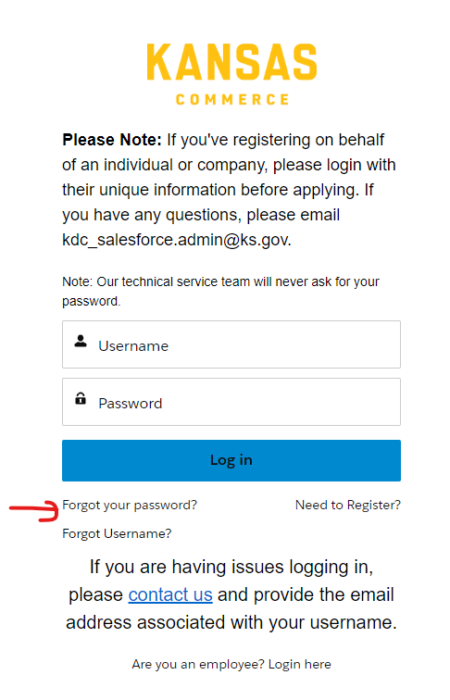
Step 3: You can see the Enter Username box, fill it with username, and click Reset Password so that you will get an E-mail for resetting your password.
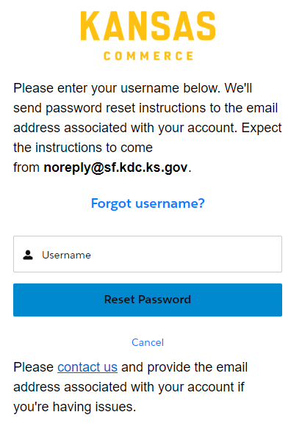

Step 4: Expect the E-mail from noreply@sf.kdc.ks.gov for instructions to reset the password. Click the link to create a new password.
Note: The link is valid only for 24 hours
Step 5: You can log into the portal using Username and Password.
Note: In case, you forgot your username, you will have the option “Forgot Username” in the login portal and follow the instructions (OR)
click on https://kansascommerce.my.site.com/Grants/s/login-forgot-username

PERFECT!!!!!!!!!! YOU GOT PASSWORD TO LOGIN!!!!!!

