APPLICANT FORGOT USERNAME
Step 1:
Go to https://kansascommerce.my.site.com/Grants/s/
(OR)
https://kansascommerce.my.site.com/Grants/s/login-forgot-username
Note: If you see the Forgot Username Page, Skip Step 2.
Step 2: While logging into the portal, if you forgot your username then click on Forgot Username? which is under the login button.
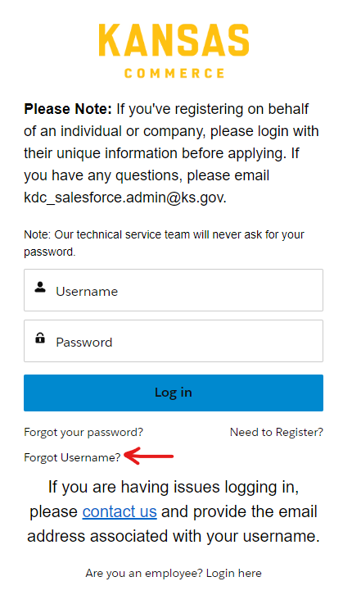
Step 3: You can see the Get Username box, click that then it asks you to enter your E-mail address.
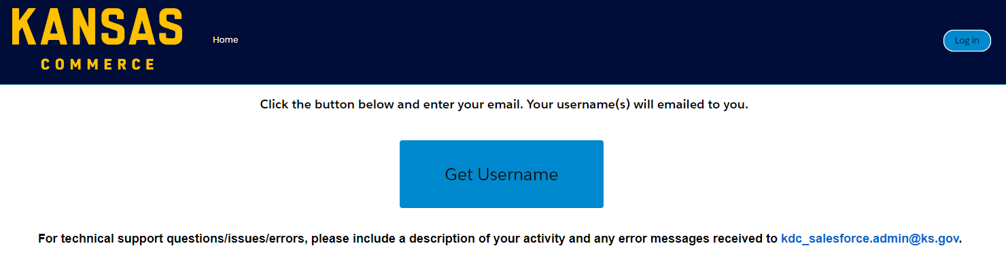

Step 4: Enter the E-mail Address then click Submit. You will receive an E-mail from noreply@sf.kdc.ks.gov which contains your Username.
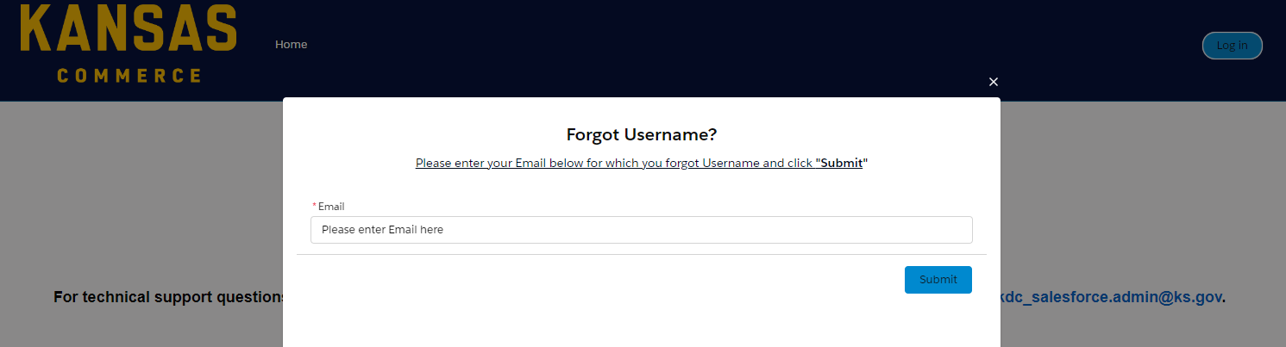

Step 5: You can log into the portal using Username and Password.
Note: In case, you forget your password, you will have the option “Forgot your Password?” in the login portal and follow the instructions (OR)
click on https://kansascommerce.my.site.com/Grants/s/login/ForgotPassword

PERFECT!!!!!!!!!! YOU HAVE USERNAME TO LOGIN!!!!!!

