Housing Physical Condition Assessment
A housing condition assessment is helpful to identify the housing needs and areas for redevelopment. The assessment looks at the exterior condition of all residential properties in an area of interest or the entire housing stock. Your committee will decide the scale to survey based on your goals, timeline, and capacity of your community.
Volunteers can either perform a walking or windshield survey for the assessment. For each residential property, a volunteer “rates” the physical condition. There are four condition categories: Excellent, Satisfactory, Deteriorated, and Dilapidated. Though it can be difficult to categorize the exterior condition of a home using only four definitions, it is important to make best efforts to be objective and consistent. Volunteers should consider the condition of the following during the assessment: foundation, roof, windows, doors, siding, porch, and the overall impression of the home.
An additional resource on conducting windshield and walking surveys is the Community Tool Box “Windshield and Walking Surveys” information page.

Surveyors should consider the condition of the following during the assessment:
Roof | Assess whether shingles or tiles are intact, whether there is any obvious sag or collapse, and whether the surveyor can see any visible  areas where patching is needed.
Siding | Determine whether siding (or other minor areas such as window frames) need painting, whether siding material is in poor condition or has holes, and whether there is any obvious bowing of walls.
Windows | Examine if any windows are broken or cracked. Note if all or some of the windows are boarded up.
Doors | Examine whether any door has been tampered with or kicked in, whether the door is no longer useable or functional.
Porches | If applicable, assess whether the home has a sagging floor, or a porch that is pulling away from the rest of the structure. Examine the condition of steps and handrails.
Foundation | Check for any visible cracks or holes in the foundation.
General Maintenance | Check for any accumulated trash, inoperable vehicles, boats or RVs in excess of what is allowed by code, fences that are learning or missing in sections, vegetation or weed overgrowth, dangerous trees or limbs, unpermitted animals, etc.

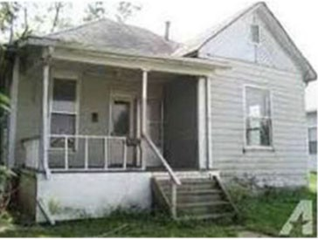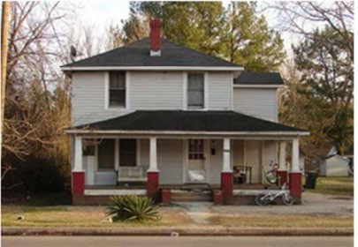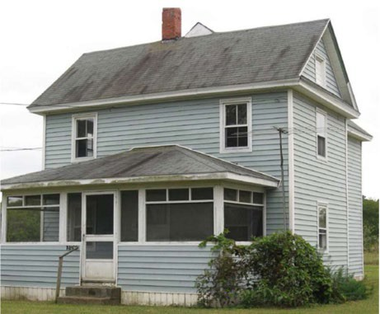
HOUSING CONDITION RATING GUIDE
RATING | DESCRIPTION / EXAMPLE PHOTOS
A - Excellent | Homes in excellent condition have solid roofs, foundations, and contribute positively to your community’s  housing stock.
Examples: | 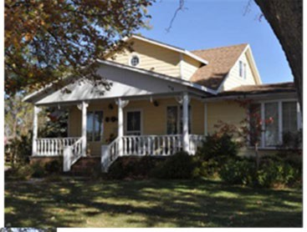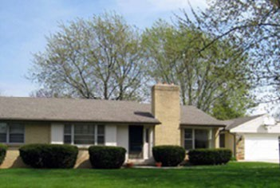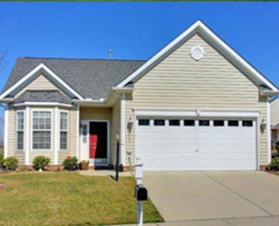
B – Satisfactory | Homes in satisfactory condition are structurally sound but may need minor repairs such as new shingles, paint, concrete steps, or doors that need replacing; does not detract from the neighborhood but does have deferred maintenance issues.
Examples:

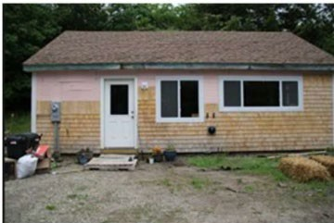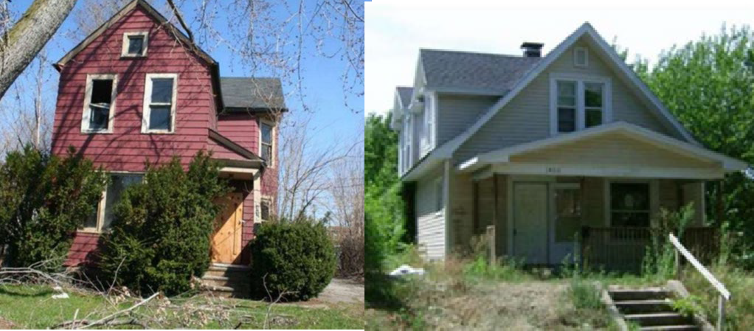
C – Deteriorated | Homes typically have two major structural problems, but the unit can still be repaired for a reasonable amount of money. The homes have substantial wear such as a sagging roof, missing or rotting siding, rotting windows, and a sagging porch; appears “tired” and gives a negative impression of the neighborhood.
Examples:
D – Dilapidated | Dilapidated homes have three or more major structural problems, but the unit cannot be repaired for a reasonable amount of money. The homes are in overall unsatisfactory condition, with a crumbling foundation, broken or rotted windows and doors, sagging roof; has extended its life beyond normal expectancy and is a  safety/health hazard.
Examples: | 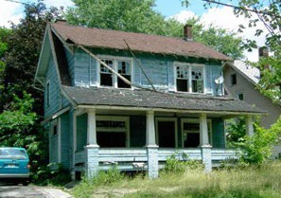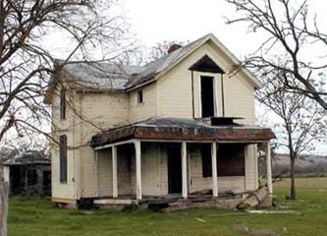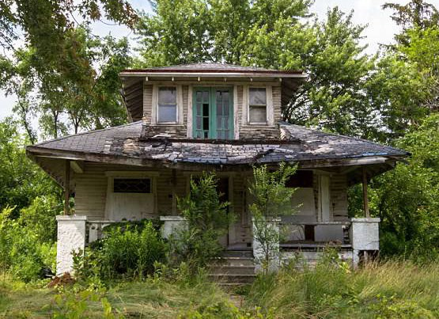

Windshield Housing Condition Assessment: Address:
ID #:
Surveyor:
Windshield Housing Condition Assessment: Address:
ID #:
Surveyor:

Type of structure:
- Single-family ☐ Mobile home
- Duplex ☐ Above commercial
- Triplex / Fourplex ☐ Vacant lot
- 5+ units

Occupancy status:
- Occupied
- Vacant
- Unknown

Tenure:
- Owner-occupied
- Renter-occupied
- Unknown

Property Condition Rating:
- Excellent
- Satisfactory (minor repairs)
- Deteriorated (1-2 major structural problems)
- Dilapidated (3+ major structural problems)

Comments:
Type of structure:
- Single-family ☐ Mobile home
- Duplex ☐ Above commercial
- Triplex / Fourplex ☐ Vacant lot
- 5+ units

Occupancy status:
- Occupied
- Vacant
- Unknown

Tenure:
- Owner-occupied
- Renter-occupied
- Unknown

Property Condition Rating:
- Excellent
- Satisfactory (minor repairs)
- Deteriorated (1-2 major structural problems)
- Dilapidated (3+ major structural problems)

Comments:

